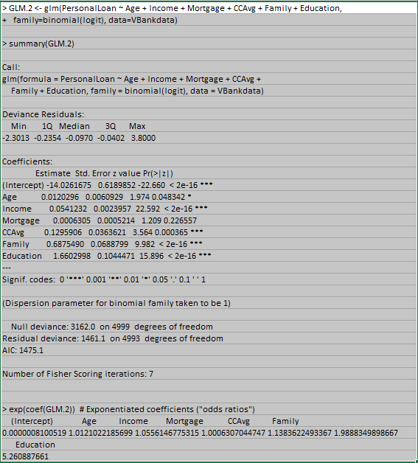

|  |  |  |  |
| --- | --- | --- | --- |
| **Logit Prediction Model** | | | |
| **Variable** | **Coefficient** | **Value** | **Coeff*Value** |
|  |  |  |  |
| Intercept | -14.0262 | 1 | -14.026168 |
| Age | 0.01203 | 45 | 0.541332 |
| Income | 0.054123 | 90 | 4.871088 |
| CCAvg | 0.129591 | 3 | 0.3887718 |
| Family | 0.687549 | 4 | 2.750196 |
| Education | 1.6603 | 3 | 4.9808994 |
|  |  |  |  |
|  |  | SUM | -0.4938808 |
|  |  | Exp(SUM) | 0.610253521 |
|  |  | Probability | 0.378979777 |

**Which variables are significant?**

The significant variables are Age, Income, CCAvg, Family size, and Education.

**How do the significant variables influence the likelihood of taking out a loan?**

As number increases for each variable, the more like the person would take out a loan and as the number decrease so does the probability:

• The higher the income level, the more likely the person would take out a loan.

* As age increases the more likely the person would take out a loan.

• The higher the credit average, the more likely the person would take out a loan.

• As the number of family members increases, the more likely the person would take out a loan.

• As the number of years of education increases, the more likely the person would take out a loan.

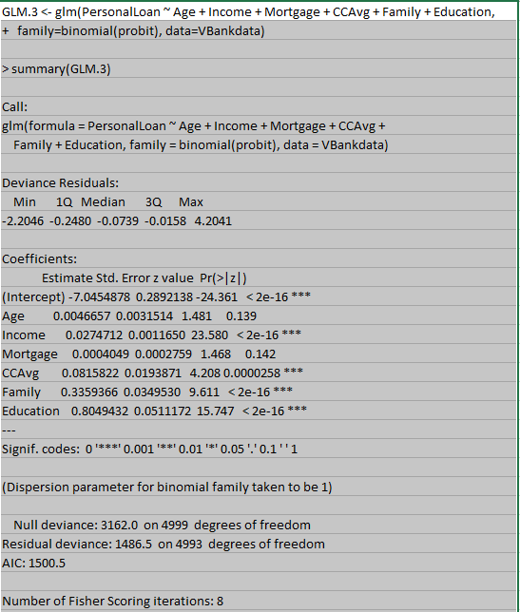

|  |  |  |  |
| --- | --- | --- | --- |
| **Probit Prediction Model** | | | |
| **Variable** | **Coefficient** | **Value** | **Coeff*Value** |
|  |  |  |  |
| Intercept | -7.0454878 | 1 | -7.0454878 |
| Income | 0.0274712 | 90 | 2.472408 |
| CCAvg | 0.0815822 | 3 | 0.2447466 |
| Family | 0.3359366 | 4 | 1.3437464 |
| Education | 0.8049432 | 3 | 2.4148296 |
|  |  |  |  |
|  |  | SUM | -0.5697572 |
|  |  | Probability | 0.284421194 |

**Which variables are significant?**

The significant variables are Income, CCAvg, Family size, and Education.

**How do the significant variables influence the likelihood of taking out a loan?**

As number increases for each variable, the more like the person would take out a loan and as the number decrease so does the probability:

• The higher the income level, the more likely the person would take out a loan.

• The higher the credit average, the more likely the person would take out a loan.

• As the number of family members increases, the more likely the person would take out a loan.

• As the number of years of education increases, the more likely the person would take out a loan.